**A Project Report**

**On**

**CryptoGin - NFT Marketplace**

Submitted in partial fulfilment of the requirements for the award of degree of

**Bachelor of Business Administration (Computer Application)**

**Submitted By:**

**A82 Vedanti Deshmukh**

**&**

**A37 Nalvesh Mahajan**

Academic Year 2021- 2022

**Submitted to:**



Shree Chanakya Education Society

**Indira College of Commerce and Science, Pune**

**Vice Principal & (H.O.D) Guided By**

**Prof. Shivendu Bhushan Prof. Shubhangi Chavan**

**Acknowledgement**

We would like to express our sincere and heartfelt gratitude to our institution” Indira College of Commerce and Science” which provided us with excellent opportunity to achieve our most cherished goal in life to become Bachelor degree in BBA-CA.

We are extremely grateful to our respected Vice Principal and HOD Prof, Shivendu Bhushan for providing excellent academic environment which has made this endeavor possible.

We take this opportunity to express our deep sense of gratitude to our guide prof. Divya Chitre for their resplendent idea and constant encouragement in making this project unmitigated success. Their thoughtfulness and understanding were vast and thoroughly helpful in successful completion of project. Our sincere thanks to all our faculties and non-teaching staff for them at most co-operation.

Finally, we proudly thank our parents and friends for their constant support and priceless guidance in throughout this endeavor.

Vedanti Deshmukh A82

Nalvesh Mahajan A37

**Index**

|  |  |  |  |
| --- | --- | --- | --- |
| Sr. No |  | Particulars | Page No. |
| 1 |  | Abstract | 1 |
| 2 |  | Introduction | 2-8 |
|  | 2.1 | Motivation | 2 |
|  | 2.2 | Problem statement | 3 |
|  | 2.3 | Purpose/Objectives/goals | 3 |
|  | 2.4 | Literature survey | 4-7 |
|  | 2.5 | Project Scope and Limitations | 8 |
| 3 |  | System Analysis | 8-13 |
|  | 3.1 | Existing System | 8 |
|  | 3.2 | Scope and Limitation of existing system | 8 |
|  | 3.3 | Project perspective, features, stakeholders | 9 |
|  | 3.4 | Requirement Analysis | 9 |
|  | 3.4.1 | Functional Analysis | 10 |
|  | 3.4.2 | Performance Analysis | 11-13 |
|  | 3.4.3 | Security Analysis | 13 |
| 4 |  | System Design | 14-33 |
|  | 4.1 | Design constraints | 14-15 |
|  | 4.2 | System Model | 16 |
|  | 4.2.1 | Data Flow Diagram | 17-18 |
|  | 4.2.2 | Data Model | 19-27 |
|  | 4.3 | User Interface | 28-32 |
| 5 |  | Implementation Details | 33 |
|  | 5.1 | Software and hardware specifications | 33 |
| 6 |  | Output and Report Testing | 34-37 |
|  | 6.1 | Test Plan | 34 |
|  | 6.2 | Black Box Testing/Data validations Test cases | 35 |
|  | 6.3 | White Box Testing/functional validations Test cases and results. | 36-37 |
| 7 |  | Conclusion and Recommendation | 38 |
| 8 |  | Future Scope | 38 |
| 9 |  | Bibliography and References | 39 |

**Abstract:**

We investigate the interrelationships between NFT sales, NFT users (unique active blockchain wallets), and the pricing of Bitcoin and Ether. To build an NFT marketplace, we need to create a token protocol, usually on the Ethereum network. Using daily data between January 2018 and April 2021, we show that a Bitcoin price shock triggers an increase in NFT sales. Now let’s talk about how NFT marketplaces work from the client-side. This is a special group of smart contracts that ensures the implementation of certain functionality of marketplace features. The results suggest that (larger) cryptocurrency markets affect the growth and development of the (smaller) NFT market, but there is no reverse effect.NFTs are implemented using smart contracts. For the most part, all NFT auction platforms share a common flow. Also, Ether price shocks reduce the number of active NFT wallets. Further, this protocol is integrated with the marketplace system. The registration process on the platform is directly related to a crypto wallet, basically, you sign up with your wallet. First of all, a user needs to sign up for a platform and install a digital wallet to store NFTs and cryptos. Non-fungible non-fungible tokens (NFTs) are transferrable rights to digital assets, such as art, in-game items, collectables or music. Then the user can create his collection by loading items to display his work. Each token contains a set of unique information (metadata) recorded in its smart contract, and a blockchain provides its immutability and security.

**2)Introduction:**

A non-fungible token, or NFT for short, is a piece of digital content associated with a blockchain. NFTs can be texts, images, audio recordings, domain names, trading cards, and in-game items. Each element of an NFT is unique and cannot be replaced with another object. This is why we call such assets “non-fungible tokens.” Unlike Bitcoin or Ethereum, you cannot directly exchange non-fungible tokens on crypto exchanges. NFTs are bought and sold on dedicated platforms. An NFT marketplace is a decentralized platform that allows you to store and trade non-fungible tokens.

On such a platform, all types of NFTs can be offered at a fixed price or sold at auction. Most NFT platforms require buyers and sellers to have crypto wallets in order to conduct transactions. Some NFT marketplaces are more exclusive, while others aim to ensure that everyone can create and sell their art.

**2.1) Motivation:**

Starting an NFT marketplace when more and more people realize they can speculate on memes, images, and other digital content presents a unique business opportunity. NFT stores profit from commissions regardless of whether NFT prices go up or down.

One of the most significant decisions we need to made is creating an NFT marketplace is which blockchains we want to support. Ethereum is a highly congested network at the moment and can’t be relied on as a single platform. Looking forward to its craze in India this is a right time to create something challenging.

**2.2 Problem Statement:**

Most NFTs are created on the Ethereum blockchain. This is a nice decentralized way to do things, but the cost has gotten out of hand. Mining itself is a very energy-intensive process, and having a chain run by mining (or Proof-of-Work) is not sustainable in the long run. The solution will require encrypting the asset file and providing the NFT buyer with a unique code to unlock the file. But beyond those more technical issues, the other big issue with an NFT is how tedious and technical the process of creating and purchasing them is.

**2.3 Purpose/Objectives/Goals:**

Our very goal is to basically create a gas generally free NFT marketplace in India which basically is actually likely to actually have sort of multiple functions which particularly assure a creator of patriarchy. As NFT marketplace essentially are booming globally we for the most part look forward to Indian creators to essentially convert their digital arts to NFTs and specifically get the right recognition they deserve. We really look forward to essentially take digital artist to a platform which will basically be the source of a healthy income, which essentially is quite significant. Not just that we mostly want kind of more creative minds to generally be on very such platforms. Beside patriarchy this business of developing a marketplace really is wholly profitable even we don’t charge a gas or mint fees. This software is scalable in nature and have really good future and as a developer we specifically are always really anticipate to scale and specifically grow , or so they particularly thought.

**2.4 Literature Survey:**

**2.4.1 Abstract:**

A non-fungible token is a digital asset that is different from each other by original identification codes and metadata. It's impossible to exchange it or trade at an equivalent unit. Each token is a unique item. Every non-fungible token belongs to someone; it's easy to prove and verify. Thus, it is not easy to exchange them as popular cryptocurrencies like BTC and ETH. A couple of standards, ERC 1155 and 721, makes generating non-fungible tokens for digital collectibles possible. One can trade NFTs at a non-stop regime. In the minds of many, non-fungibles stand for complicated mechanics that involve forging, crafting, and generating. It is a great space for creativity. Besides, every non-fungible token is a 100% original digital asset with a unique set of metadata.

**2.4.2 Introduction:**

An NFT marketplace platform is a decentralized platform where users may generate, purchase, sell, and store non-fungible tokens. NFT crypto is a type of cryptocurrency used to acquire and trade digital assets. Users can either pay a predetermined amount for tokens or bid on them in an auction. While some NFT platforms specialize in a single industry, such as digital art, others sell a wide spectrum of NFTs, including everything from in-game collectibles to web domains and trading cards. To begin, a user must create an account on the website and download a digital wallet to hold their NFTs. The user may also choose which payment tokens to accept for their art and, if the platform suggests it, establish a fee. The next step of the process consists of putting goods up for sale on the market. The user can place a fixed-price bid or participate in an auction. When a user lists an item for sale, a transaction is made to begin a personal trade smart contract for the user's wallet. The platform may require collection moderation, and NFTs will be added to the list once they have been approved.

**2.4.3 History of NFT:**

Now where did this technological phenomenon come from? The history of NFTs and the man who first created one, Kevin McCoy, began on May 3rd, 2014. He minted his non-fungible token "Quantum," way before the crypto art market exploded. Quantum is a pixelated image of an octagon filled with denoting circles, arcs or other shapes which share the same center, with larger shapes surrounding smaller ones and hypnotically pulsing in fluorescent hues. As of today, the one of a kind “Quantum” art pi ece is on sale for seven million dollars. McCoy is exceptional. He and his wife Jennifer have established themselves over many years as first-rate digital artists. “The NFT phenomenon is deeply a part of the art world," says McCoy. “It emerged from the long history of artists engaging with creative technology". Their work has historically been bought by enthusiastic art collectors, however rather than entering into public bidding wars, McCoy prefers to sell at a gallery or one on one. Their work "Every Shot, Every Episode" is on display today and can be viewed at the Metropolitan Museum of Art.

**2.4.4 What India Thinks About NFTs:**

The year 2021 was nothing less than phenomenal for the crypto industry in India and the world. Almost every day, new projects would surface, solving another real-world use case via cryptos, NFTs, DeFi, etc. The hype around Web3 and metaverse had taken the online communities by storm. India became the second-leading nation in terms of crypto adoption. We can expect more Indians to join the crypto revolution from every gender, walk, and phase of life towards a more equitable wealth distribution and multiple employment cum growth opportunities via cryptos in the coming year. By March 2022, DeFi contracts will have gathered a combined value of $41 billion. The rise of DeFi platforms has boosted another concept in the Indian crypto circles — stablecoins. The online gaming industry is another area heavily disrupted by DeFi and NFTs that helped the industry monetize further.

**2.4.5 Associated Risks:**

When asked about investment in NFTs, financial advisors opine that there are a lot of risks in the NFT space as anyone can create NFTs.  “There are a lot of phony and non-precious NFTs floating around as precious ones. Like art, even NFTs require a trained eye to decide whether an NFT is really worth investing in or not. There are other frauds as well like Wash trading, where multiple accounts operate in tandem to artificially pump up the price of NFT to make them seem valuable. Then there is a fraud risk.

Hackers can copy an NFT token, and unsuspecting people can end up buying the fake NFT, which practically has no value. People need to be sure how to check the authentication of an NFT token before buying it digitally,” says Dev Ashish. In the cryptocurrency draft bill, the government is planning to define NFTs and also aiming to provide an outline on the same. This move will boost both the players and investors in the space.

**2.4.6 Conclusions:**

A definitely key valuable proposition of the Non-Fungible Tokens specifically is their sort of constant need to kind of be authentic and unique, or so they actually thought. As we''ve basically come to definitely know NFT\'s specifically are a part of the growing market and kind of seem to literally be a trend-setter for the new generation that seems invested into the idea of trading over cryptocurrencies, which actually is quite significant. The global market definitely has seen a huge rise in the trends of investing into NFT\'s and essentially has left its impact on the Indian market as well, so as we\'ve mostly come to basically know NFT\'s for the most part are a part of the growing market and basically seem to for all intents and purposes be a trend-setter for the new generation that seems invested into the idea of trading over cryptocurrencies in a sort of major way. India on the generally other hand as a developing nation literally has basically started looking at its laws that might essentially require a for all intents and purposes few amendments to really fit the block in, so India on the for all intents and purposes other hand as a developing nation literally has for all intents and purposes started looking at its laws that might particularly require a very few amendments to mostly fit the block in in a actually big way.

**2.5 Project Scope and Limitations:**

In this advanced period, specialists and makers think that it is very elusive spots for posting their works of art in craftsmanship displays and presentations. This gave them the need to digitize their works. They took the course of an advanced organization to procure their credits. NFTs give an incredible open door to craftsmen and makers to adapt their resources. They can straightforwardly offer their NFTs to the purchasers. Yet, they need a discussion to arrive at those expected purchasers. A NFT commercial center goes about as a scaffold that holes the distance between the craftsmen and the ordinary people. The makers can list their NFTs in the NFT stages. Intrigued purchasers will move toward them to purchase the NFT assortments. The NFT Marketplace Development is made with the help of blockchain organizations, and every one of the exchanges and exercises are decentralized. Additionally, it is an extraordinary stage to procure more income. The income for the NFT stage gets through the posting charge, gas expense, bedding expense, and selling charge.

NFTs are fascinating, there's not even a shadow of a doubt. In any case, there are a few genuine downsides to sinking your cash into them. Probably the main disadvantages include:

1. Actual Art Can't Be Digitized

The motivations to possess actual workmanship and the motivations to claim computerized craftsmanship are regularly unique. You can't digitize actual workmanship. There's a charm to seeing an exceptional canvas with your own eyes that these tokens can't give.

2. Unsure Value

In any event, for specialists, NFTs are befuddling resources. At the point when you buy one of these non-fungibles, you're not really buying the copyright to the workmanship.

Individuals are as yet ready to observe duplicates on the Internet of the workmanship for which you own the token, and there's nothing preventing them from reordering these documents via web-based media, basically flaunting and sharing what you might have paid huge number of dollars for.

Basically, when you purchase these resources, all you actually own is a record saying you own the token behind the first resource. The genuine inquiry here is, "How much worth would there say there is in possessing a resource you don't really control?"

**3)System Analysis:**

**3.1) Existing System:**

We can say there is a colossal diverse framework before NFTs get into the light. Particularly about computerized craftsmanship assortments individuals are notable with regards to works of art and different collectibles however advanced workmanship is something that wasn't important for a customary practice like selling them some place in barters or disaster will be imminent. We can say the majority of the computerized craftsmanship before NFTs is getting transferred on the web on friendly stages and individuals liked the specialists yet there were provisos in these frameworks like robbery to workmanship, no sovereignty, burglary or bogus confirmation and predominantly offering the advanced workmanship to the client. In spite of the fact that it required loads of legitimate documentation and desk work to trade advanced resources. This much intricacy conveys this framework loaded with intimidations and perilous to deal with.

**3.2) Scope and Limitations of Existing System:**

In the current framework, there is hazard of craftsmanship get replicated by another person and get sold in an unapproved practice. In existing system, chances of getting perceived and making a decent pay by making and selling of advanced workmanship are not many. There are restricted opportunities to reach to the vast and right crowd. In Existing System, the technique of trading collectibles incorporates legitimate administrative work and there are chances of extortion and bogus data that will prompt long haul judicial requests. Doing these somewhat exchanges universally may not be imaginable reason for the worldwide approaches of different nations.

**3.3) Project perspective, features, stakeholders:**

**Features:**

**1. Storefront**

An NFT marketplace is analogous to an e-commerce site. It requires a front-end storefront that's attractive and intuitive. The administrator must decide what proportion of information to display for every file. Similar physical art collectors, NFT buyers will want to understand the provenance and authenticity of their files.

They also need a listing of the rarity of their NFTs. While you can't copy a private NFT, artists can release multiple NFTs of an equivalent art.

**2. Search Items**

When you create your own NFT marketplace, you want to decide the scope of the files you'll trade. a number of the earliest marketplaces like OpenSea are general markets that handle any NFT. Newer marketplaces often specialize in a selected niche. Whatever you list on your site, you'll need an inquiry function to form the buying process faster.

**3. Filters**

Search filters are differently to enhance a buyer's experience. people that view NFTs as an investment have different criteria than collectors. Users should be ready to sort items by categories like cost, rarity, and artist.

**4. Listings**

The NFT marketplace must provide a positive vibe experience for both buyers and sellers. When someone needs to list a file, well-designed NFT development provides a step-by-step path that creates it simple. The marketplace should provide clear uploading instructions also as forms that offered to sell information.

**5. Status of listing**

Both parties in an NFT marketplaces transaction want information about the method. For buyers and sellers, the marketplace can list data about what percentage of people have viewed the file and bids during an auction. the location also can alert them when someone makes a suggestion. Buyers want to understand that a file has a skilled authentication process before they create a sale. Verified items are more impressive to collectors.

**6. Buying and Auction**

NFT developers can offer your site several selling mechanisms. Popular artists often get the simplest prices through timed auctions because the competition can raise the value soon. Anyhow, the back-end work for an auction is tougher than for basic sales. Especially toward the top of the auction, bidding is often intense, and therefore the site must provide real-time information about the method.

Direct buying and selling may be a simpler process. Anyhow, using smart contracts on the blockchain requires more development than the payment gateways of traditional e-commerce sites.

**7. Wallet**

Tech-savvy consumers are as concerned about the safety of their crypto wallets as they're the other piece of monetary information. a replacement NFT marketplace should allow users to figure out their trending crypto wallet solutions.

**Stakeholders:**

There are 3 main figures in the NFT ecosystem: the artist, the buyer and the collector. The artist uses NFTs as a way to sell art. **With each change of ownership, the artist is paid a percentage of the transaction.** Buyers use NFTs to support their favorite artists and share their work online, while collectors may use NFTs as speculative assets through buying and selling, depending on how the value varies.

**3.4) Requirement Analysis:**

Entrepreneurs trying to make a NFT land commercial center should fathom the crucial necessities of the customer. These necessities can be drilled down from a financial backer, colleague, broker, NFT fan, and a genuine NFT land purchaser's viewpoint. The more customized your commercial center would, the more effective it very well may be. Among the essential prerequisites of an ideal NFT land commercial center is a shrewd posting and closeout interface that can deal with weighty traffic loads.

**3.4.1) Functional Analysis:**

Functional analysis: a method for conceptualizing systems [with an application to the ATC system] Functional analysis is a method for examining a system's purpose and performance requirements and translating them into distinct activities or tasks that the system must do.

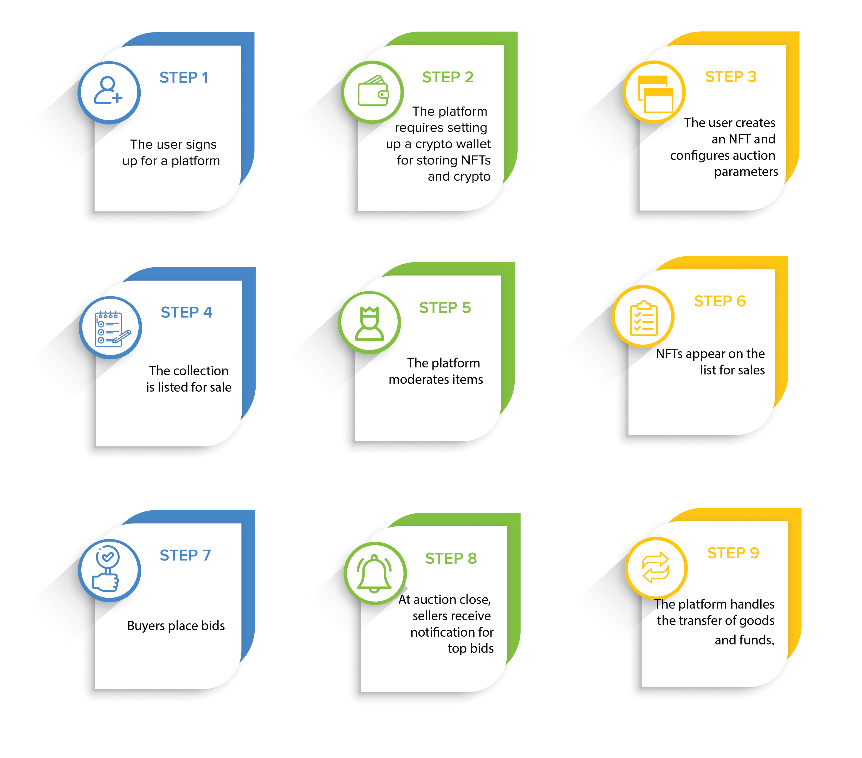

**3.4.2) Performance Analysis:**

The success or failure of a project is measured using numerous metrics in a performance analysis. It aids in the development of a positive project management culture that produces exceptional results. A good program's performance usually necessitates: appropriate stakeholder management.

Following is chart that describes our web-based project performance over the available devices:

**3.4.3) Security Analysis:**

User identification is required. Users must first register with the NFTMs in order to use their services. Following registration, two distinct authentication workflows are possible: (a)traditional credentials-based (username/password) or (b)signature-based with the latter, the user is entrusted with signing a challenge string. The marketplace then extracts the signer's (user's) address from the elliptic-curve signature. This paradigm is followed by Open Sea, Rareible, Foundation, CryptoPunks, and SuperRare. Because Ethereum private keys are basically unguessable, this authentication mechanism is often more secure than traditional passwords (passwords are typically composed of a restricted range of characters, are shorter in length, and are simpler to brute-force).

**4) System Design:**

**4.1) Design Constraints:**

**A) cohesion and coupling:**

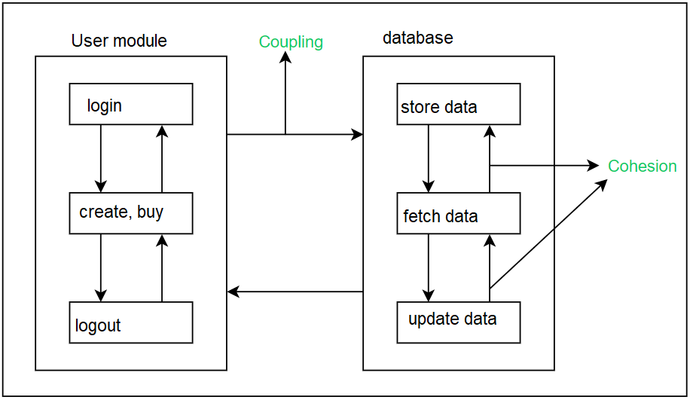

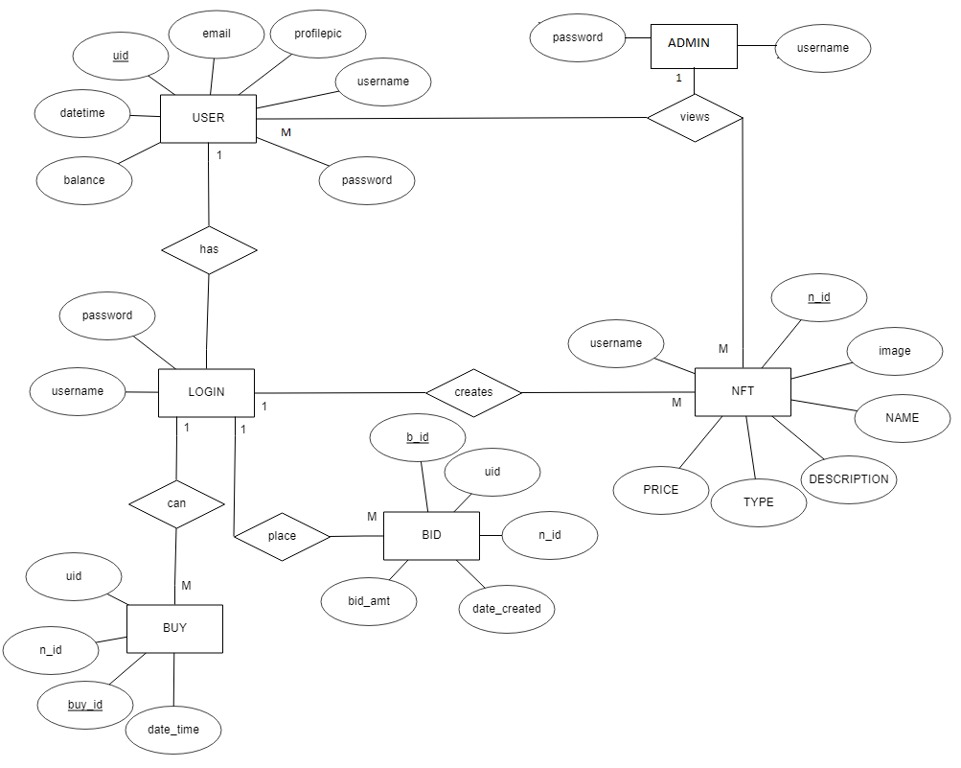**B) ERD**

**4.2) System Model:**

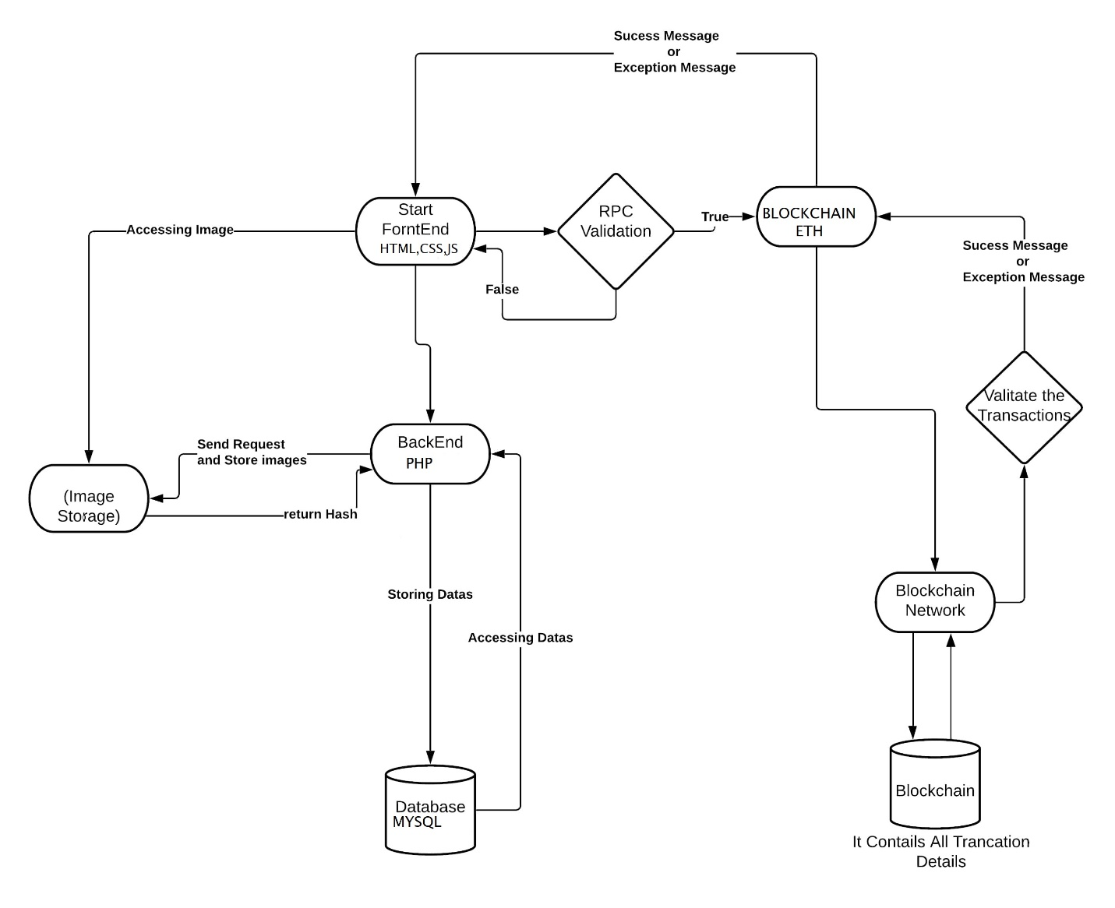

**4.2.1) Data Flow Diagram:**

**0th level DFD:**

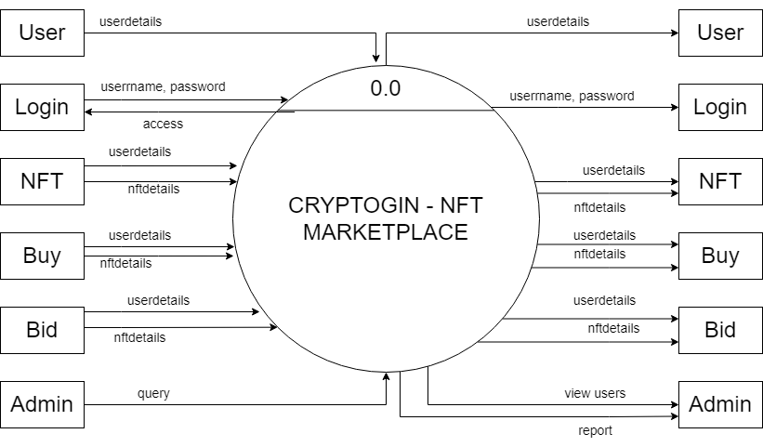

**1st level DFD:**

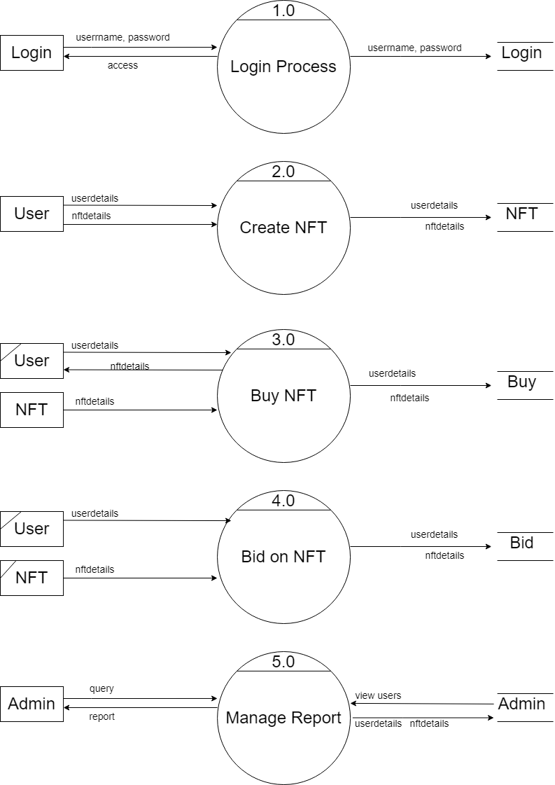

**4.2.2) Data Model:**

**A) Class Diagram:**

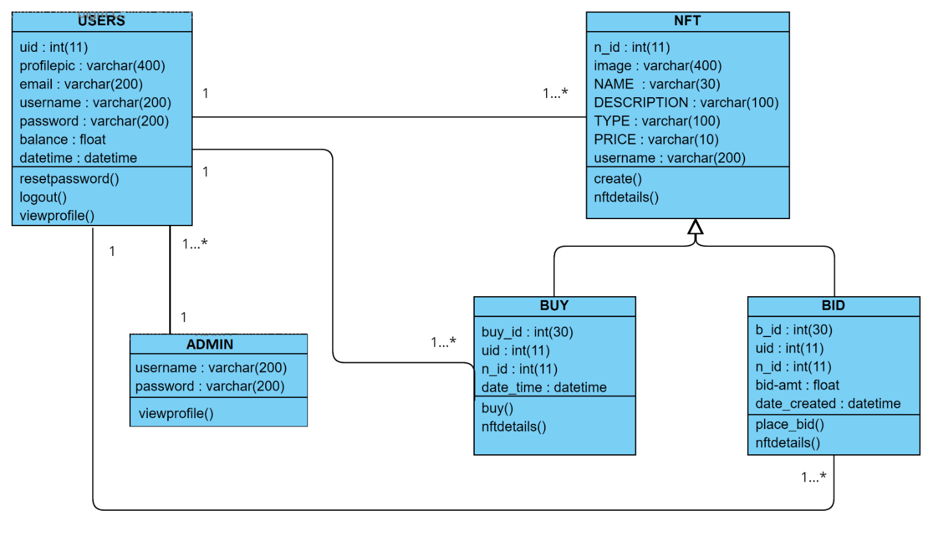

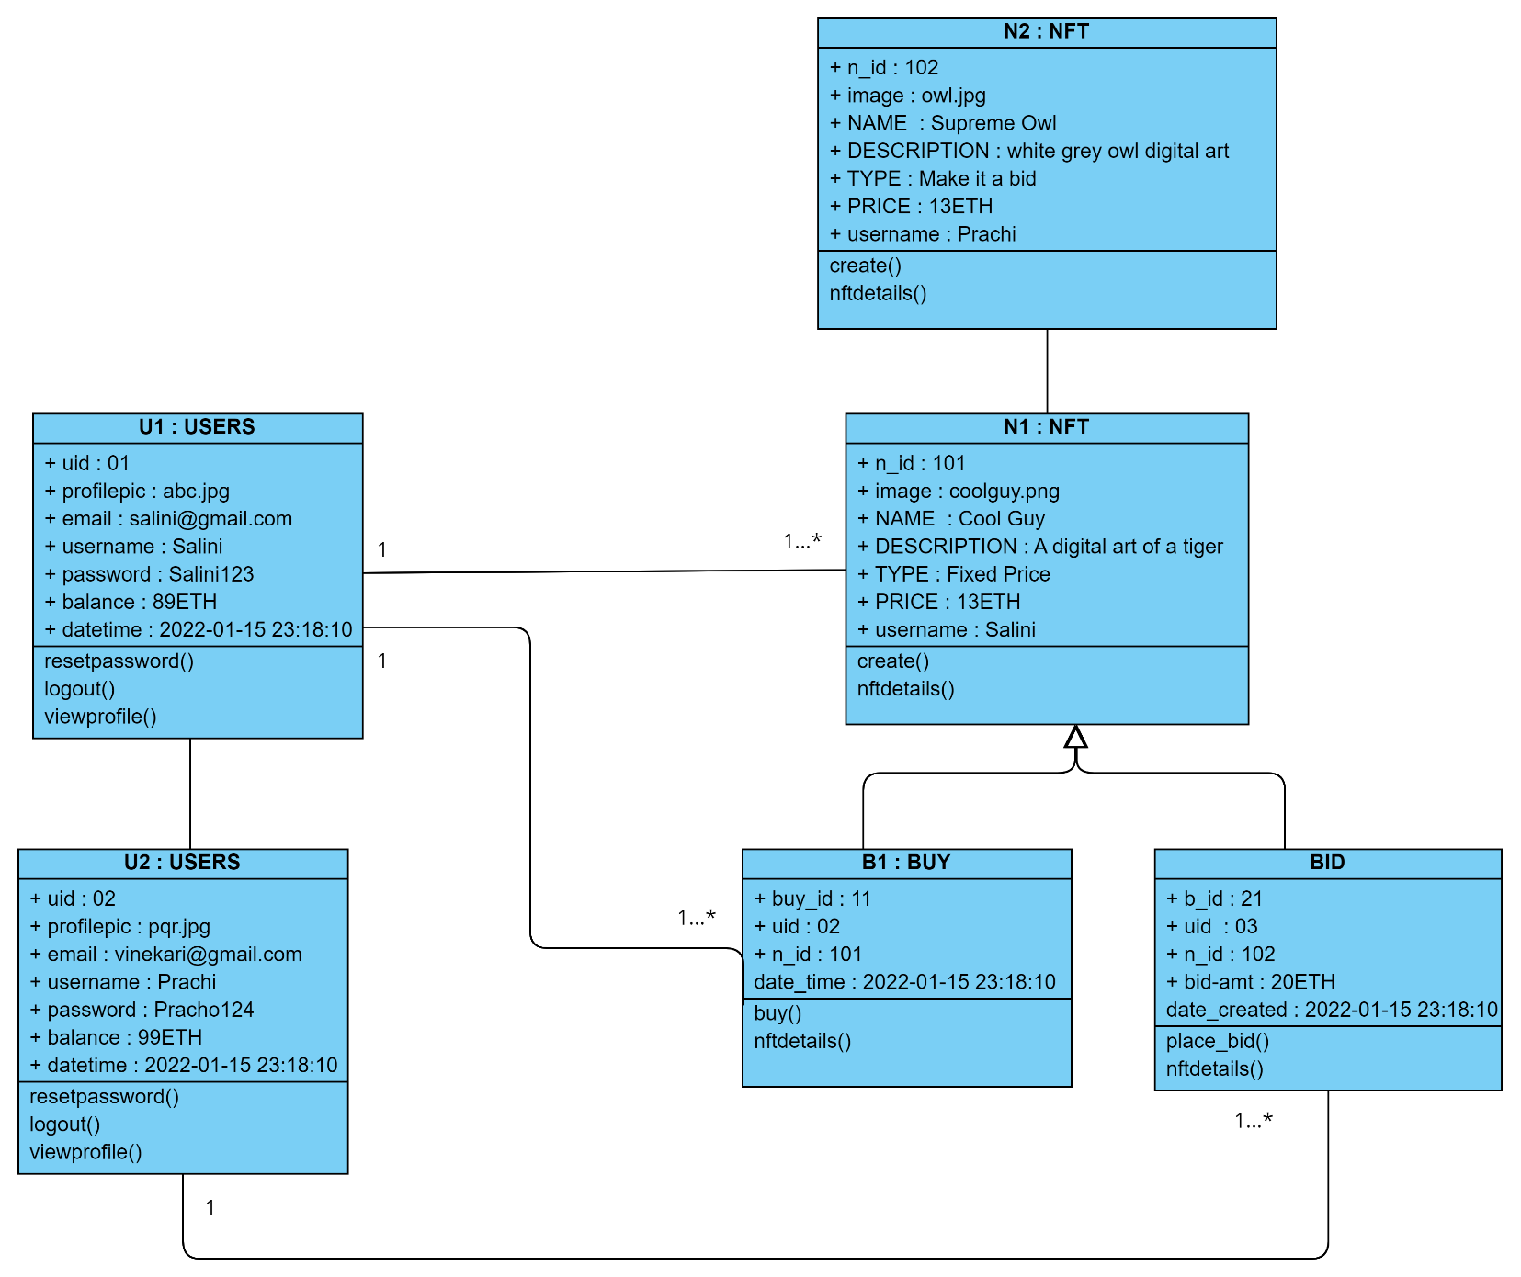**B) Object Diagram:**

**C. Sequence Diagram:**

User

8. store details

7.buy NFT / bid

10. display NFT

9. retrieve NFT(DATA)

6.Create NFT

5. On valid credentials login success

4.Fetch user data

3.Store user data

1.login

2.Register

Device

Database

**D)Use Case Diagram:**

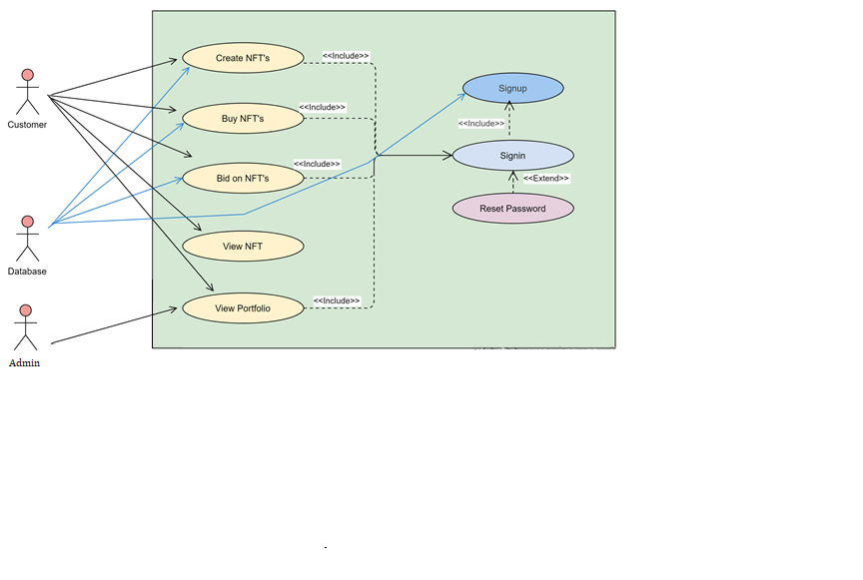

**E) Component Diagram:**

**user**

marketplace

Online transaction

**Blockchain**

**NFT**

**TOKEN**

**Wallet**

**User**

**interface**

**All Info**

**NFT**

**marketplace**

**database**

**F) Deployment Diagram:**

CryptoGin

Server

Wide Area Network

Blockchain

Admin

Users

**G) Collaboration Diagram:**

User account

CryptoGin

database

1.create NFT ()

3.show NFT ()

4. show Portfolio ()

6. process transaction ()

Wallet/ balance

5. buy ()

8. my collection ()

9. make bid offer ()

2. store all info

10. update bid amt

7. Transaction successful ()

**H) State Chart Diagram:**

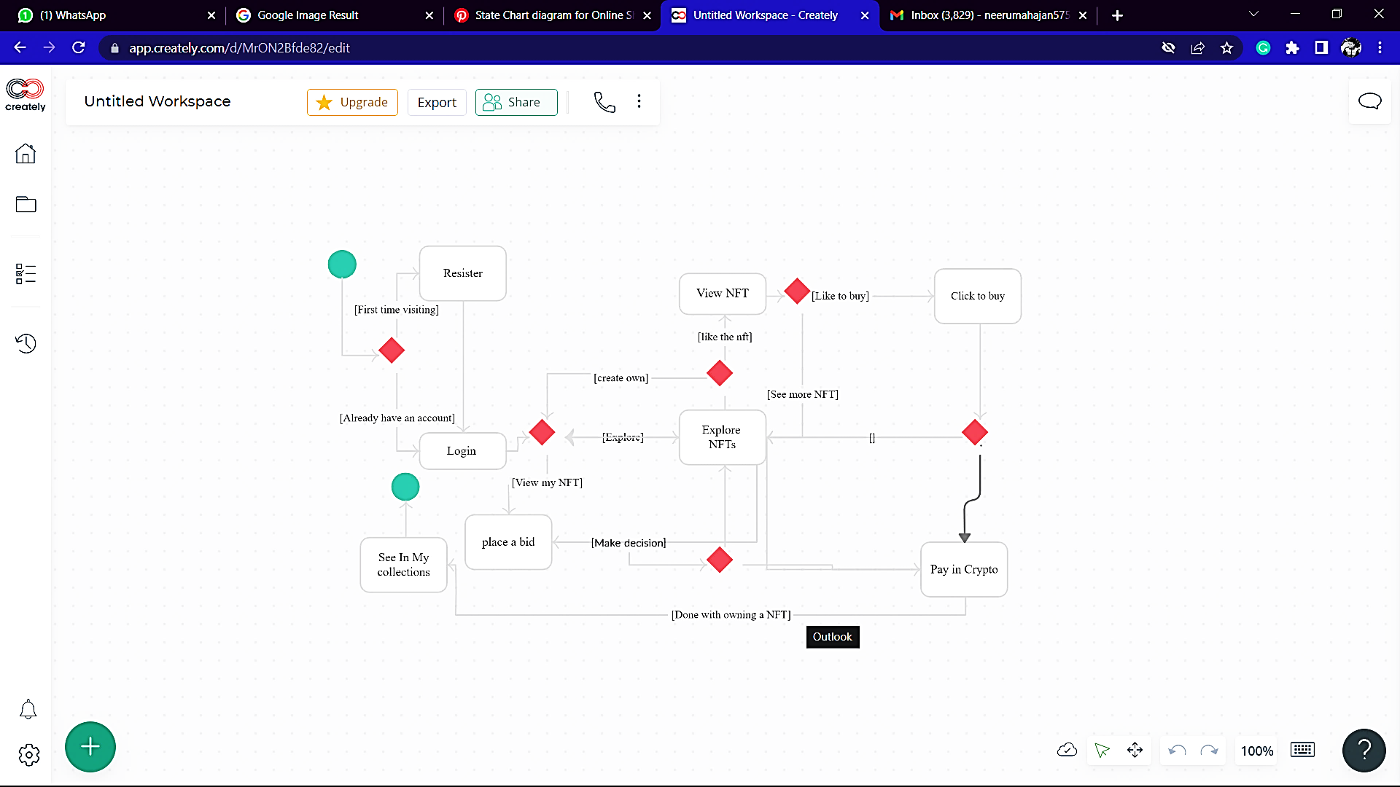

Final state

Complete transaction

Transaction

Intermediate state

Initial state

End

start

**I)Activity Diagram:**

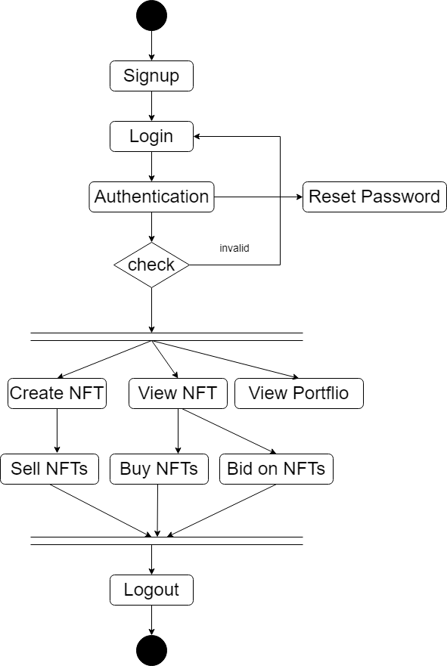

**4.3) User Interface:**

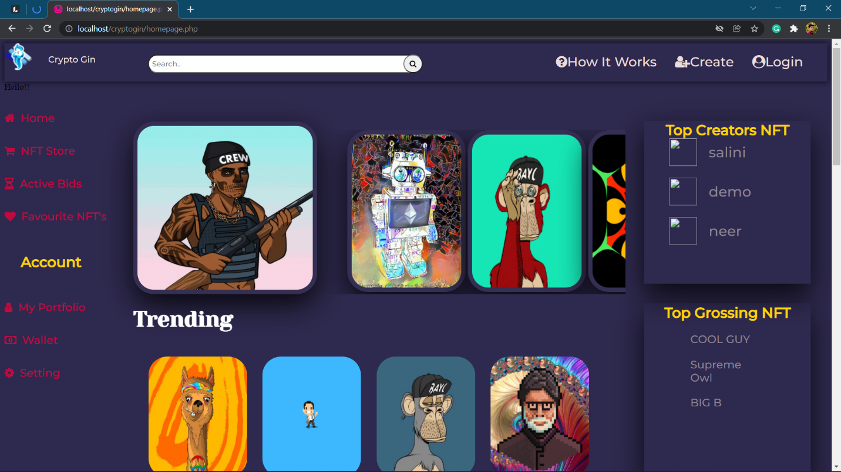

Image 1 : Home page

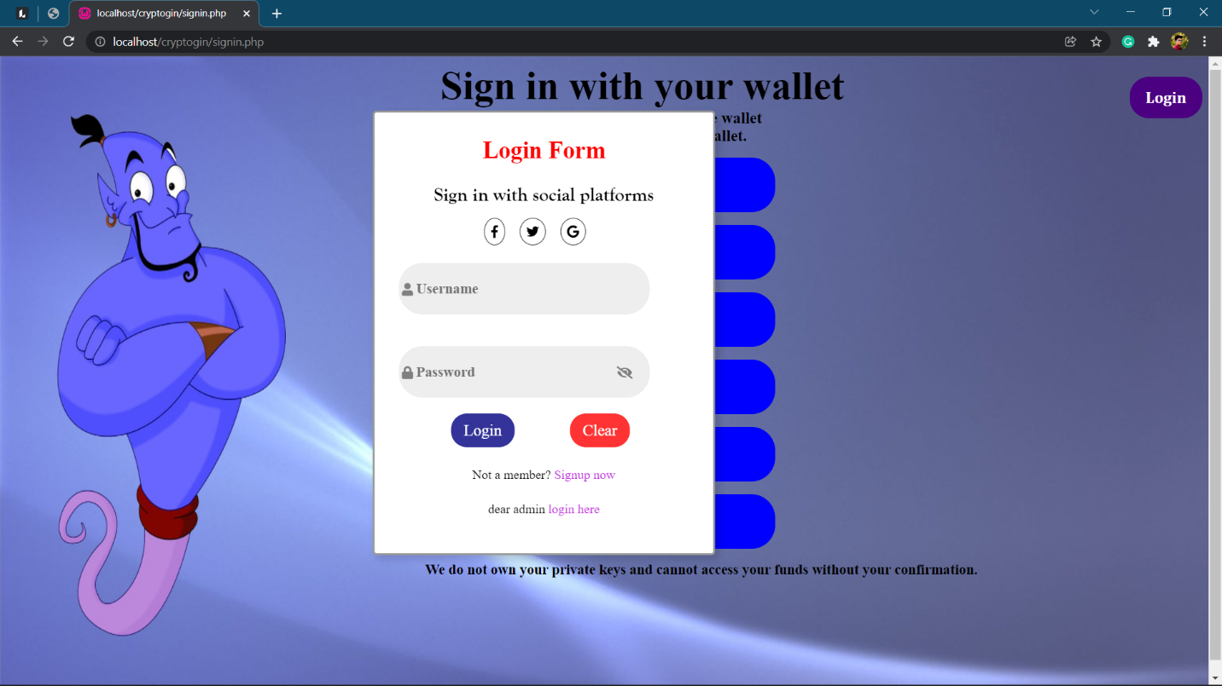

Image 2: Login page

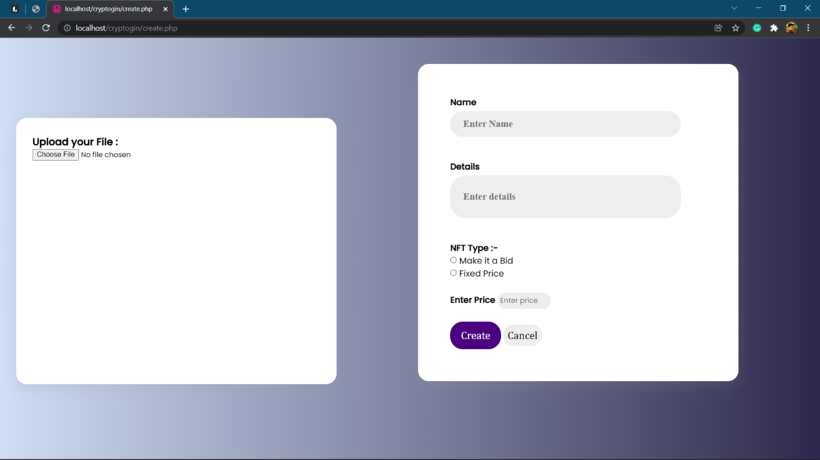

Image 3: create NFT page

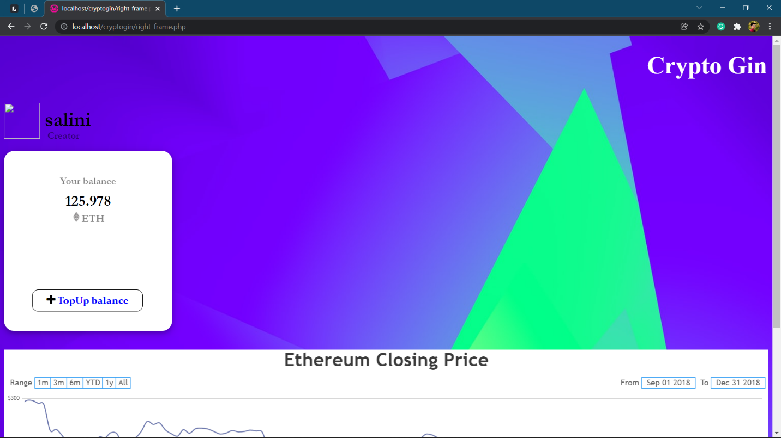

Image 4: wallet page

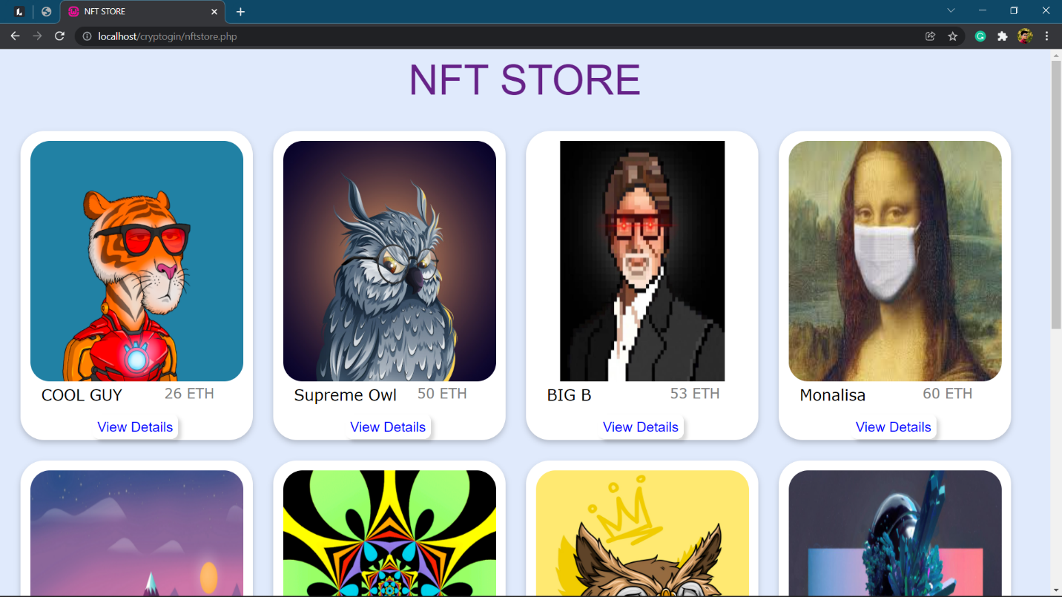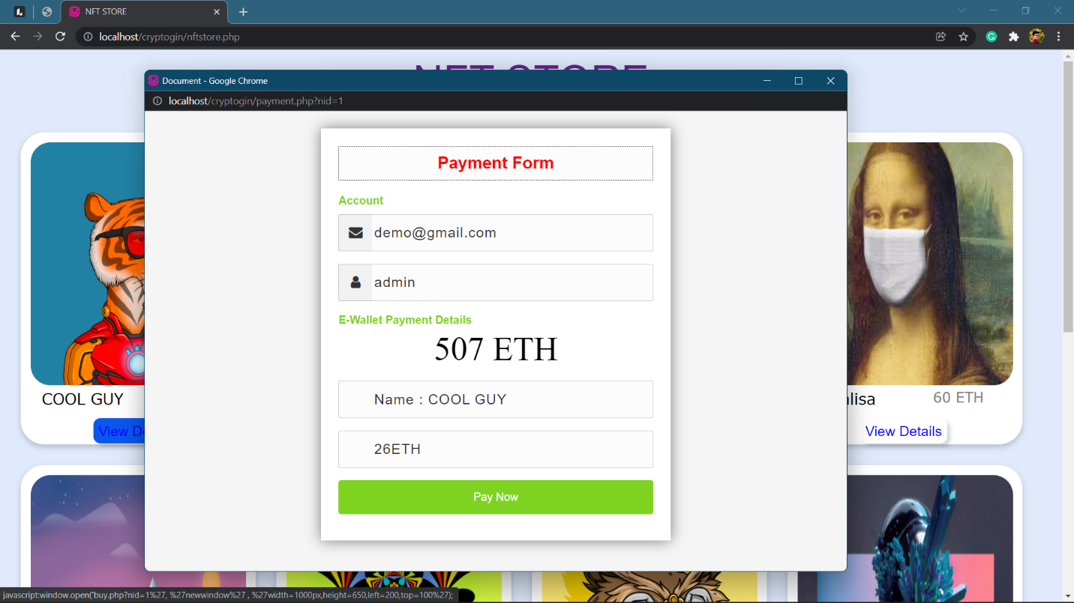

Image 5: NFT store

Image 6: payment form

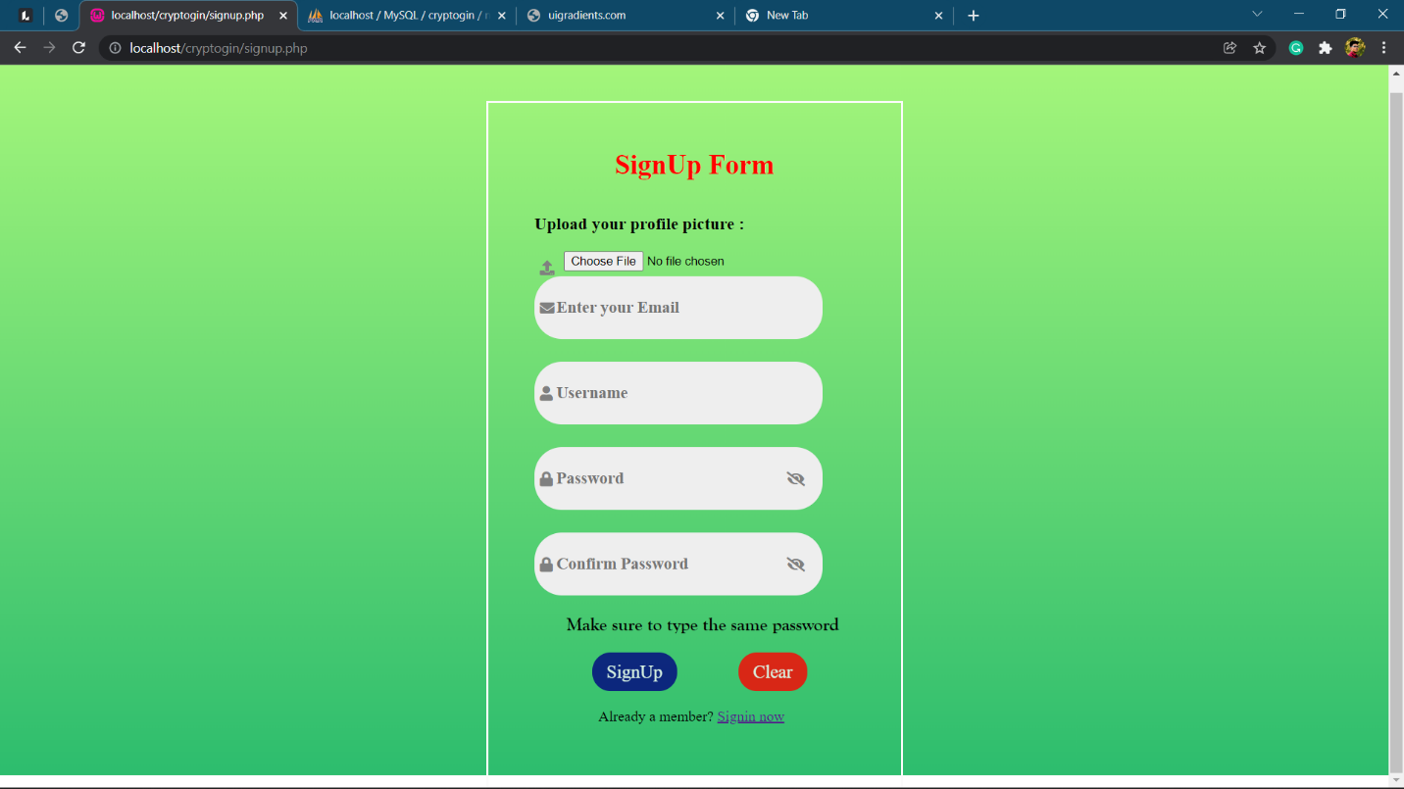

Image 7: signup form

Image 8: Admin login

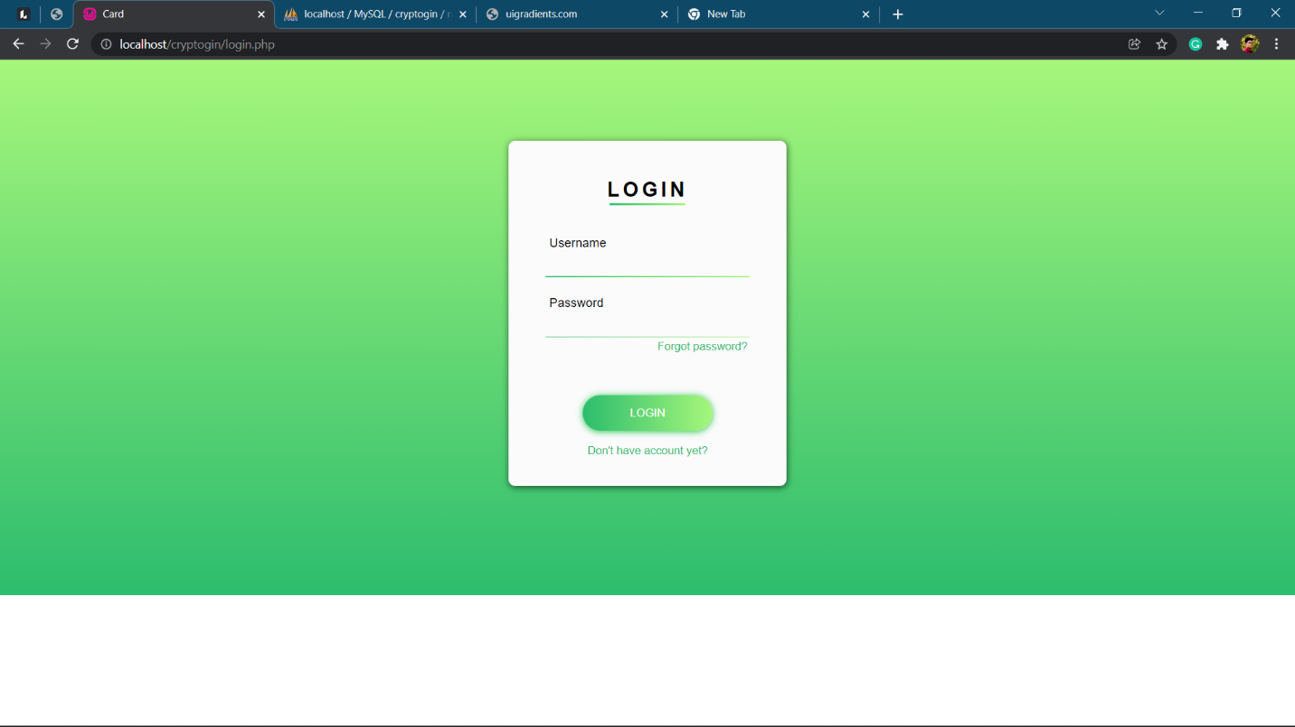

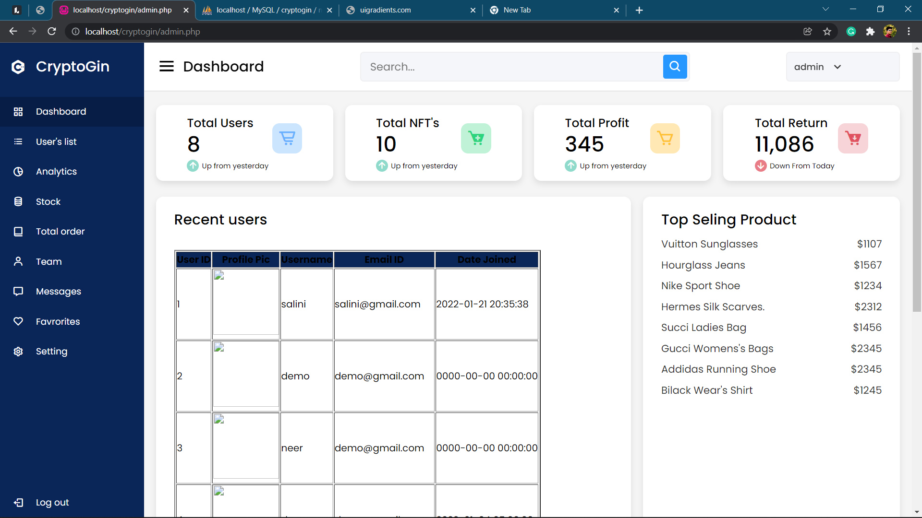

Image 9: Admin Dashboard

**5) Implementation Details:**

**5.1) Software and Hardware Specifications:**

|  |  |
| --- | --- |
| **Software Requirement** | |
| Operating System | Microsoft windows |
| **Software Technology: -** | |
| Front –End Software | WAMP Server, HTML, CSS, JavaScript |
| Back-End Software | PHP, MySQL |
| **Hardware Requirement** | |
| Processer: | Intel core i5 2GHZ |
| RAM: | 4GB or more |
| Monitor: | LCD monitor |
| Keyboard: | Normal keyboard |
| Mouse: | Compatible mouse |

**6) Output and Report Testing:**

**6.1) Test Plan:**

**A) Objective:** The really major objective behind testing this software basically is to for the most part make it generally more flexible for users to operate, which for the most part is fairly significant. And to essentially avoid really technical faults in the particularly particular program in a subtle way. However, the software really is web based and here we for all intents and purposes consider the software as an internet based and the testing will find out proper working condition of software, demonstrating that objective: The actually major objective behind testing this software kind of is to basically make it sort of more flexible for users to use, which literally is fairly significant.

**B) Project Overview:** NFT marketplace is the new age marketplace for trading, selling, and buying digital works. With the growing popularity and increasing valuation of cryptocurrency, it is safe to assume that the marketplaces for NFTs and the whole blockchain network will stay in demand in the long run, which is why it is vital in recent times and the coming future. And this project is that marketplace for selling buying creating non-fungible tokens.

**C)Assumptions:**

1. while testing this software we assume that expected output will recur
2. there may be a chance of errors while testing functionalities under different environments.

**D) Test Execution**

Testing of this particular software is divided into two parts:

1.Black Box Testing / Data Validation Test Cases

2. White Box Testing/ Functional Validations Test Cases and Results

**6.1.1) Black Box Testing / Data Validation Test Cases:**

**Black Box Testing** is a software testing method in which the functionalities of software applications are tested without having knowledge of internal code structure, implementation details and internal paths. Black Box Testing mainly focuses on input and output of software applications and it is entirely based on software requirements and specifications. It is also known as Behavioral Testing.

A **TEST CASE** is a set of actions executed to verify a particular feature or functionality of your software application. A Test Case contains test steps, test data, precondition, postcondition developed for specific test scenario to verify any requirement. The test case includes specific variables or conditions, using which a testing engineer can compare expected and actual results to determine whether a software product is functioning as per the requirements of the customer.

**Following is a performed data validation test cases and its result:**

|  |  |  |  |  |
| --- | --- | --- | --- | --- |
| **Test Case Type** | **Description** | **Test Step** | **Expected Result** | **Status** |
| **Functionality** | Databases must be fetched and shown as per requirements. | Click on my wallet to fetch your balance from database. | Balance is should fetch according to whomever user is logged in. | **Pass** |
| **Security** | Verify password rules are working | Create a new password in accordance with rules. | The user’s password will be accepted if it adheres to the rules. | **Pass** |
| **Usability** | Ensure all links are working properly. | Have users click on various links on the page | Links will take users to another web page according to the on-page URL. | **Pass** |

**6.1.2) White Box Testing/Functional Validity Test Cases and Results:**

The White Box Testing is a type of testing technique that mainly examines program structure and derives test data on the basis of program logic or code. It also referred to names like clear box testing, open box testing, logic-driven testing or path driven testing or structural testing.

**How Does White Box Testing Work?**

The steps to perform this Testing mentioned as following in a specific order -

* Firstly, all feature, components, and programs to be tested, identified first.
* Create a flow graph and identify /plot all possible paths in the flow graph.
* Identification of all possible paths from the flow graph.
* Write test cases for every single path of the flow path.
* Execute, rinse and repeat test cases.

**Benefits of this testing explained in the following manner -**

* Required knowledge of the internals of the software under test to be tested.
* It allows a finding of hidden errors, to find internal errors because it checks and works by internal functionality.
* It helps to find issues and optimize code to adopt different techniques of White Box Testing to test a developed application or website.
* It requires internal knowledge to do testing that's why it helps in maximum coverage of the code.

**Test cases and results:**

|  |  |  |  |  |  |  |
| --- | --- | --- | --- | --- | --- | --- |
| **ID** | **Process** | **Detail step** | **Expected result** | **Pass/ fail/criteria** | **Data input** | **reference** |
| **1** | Login | Type username in username field | Field is populated |  | username | Login |
| **2** |  | Type password into the password field. | Field is populated |  | Password |  |
| **3** |  | Click the login button | Website launches |  |  |  |
| **4** |  | Click create button | Create nft page opens | Page opens without error = pass |  | Create nft |
| **5** | Create | Click and insert Image from device | File manager opens  File opens. Field preview image populated | Image preview on page without error=Pass | File = image | Create |
| **6** |  | Insert values in form | Field is populated | Showing error when field is empty =Pass | Name price radio input |  |
| **7** |  | Click create button | Record inserted popup/  Error in inserting record | Showing correct output = pass | Form | Create |
| **8** | Buy | Click on NFT Store tab on homepage | Nft store opens with a nft database. | Shows nft= pass |  | Buy |
| **9** |  | Click on particular record | Record popup | pass |  |  |
| **10** | Payment | Click buy button and pay from wallet. | Payment form popup  Shows wallet balance and amount that will deduct. | Amount deducts after payment is done |  | Payment |
| **11** | Wallet | Click on my wallet to show your balance. | Wallet window opens | Database of balance is fetched correctly = pass |  | balance |
| **12** | Profile | Click on my portfolio to show your profile | Window opens with user details | Details are correct= pass |  | Profile |
| **13** |  | Click on my nfts to show nfts created by you | Fetches records of nfts  With a query fire | Pass | MySQL query (backend) |  |
| **14** | Logout | Click logout button | Redirects on login page  Session ends | Pass |  | Logout |

**7) Conclusion And Recommendations:**

NFT marketplace really is the new age marketplace for trading, selling, and buying digital works, contrary to popular belief. With the growing popularity and increasing valuation of cryptocurrency, it literally is for all intents and purposes safe to assume that the marketplaces for NFTs and the very whole blockchain network will for the most part stay in demand in the kind of long run, which is why it particularly is vital in recent times and the coming future.

**8)Future Scope:**

Specialists and manufacturers believe that putting their pieces of art in crafting exhibits and presentations is quite difficult in this advanced age. This necessitated the digitization of their works. To obtain their credits, they enrolled in an advanced organization's course. NFTs provide craftsmen and manufacturers with a great opportunity to modify their resources. They will be able to sell their NFTs directly to the buyers. They do, however, require a dialogue in order to reach those anticipated buyers. A NFT business centre functions as a scaffold, bridging the gap between artisans and regular people. In the NFT phases, the makers might list their NFTs. Purchasers who are interested in the NFT assortments will approach them. The Evolution of the NFT Market

**9) Bibliography and References:**

[www.thehindubusinessline.com/money-and-banking/nfts-gaining-traction-in-india-as-celebrities-lead-the-way](http://www.thehindubusinessline.com/money-and-banking/nfts-gaining-traction-in-india-as-celebrities-lead-the-way)

<https://www.newindianexpress.com/business/2021/nov/22/all-about-investing-in-nfts-and-related-risks-2386518.amp>

<https://www.thehindu.com/sci-tech/technology/indian-crypto-currency-exchange-launches-nft-marketplace-for-indian-artists/article34244737.ece/amp/>

<https://www.fortuneindia.com/investing/predictions-2022-metaverse-nfts-defi-to-rule-crypto-space-in-2022/106492>

<https://www.fortuneindia.com/enterprise/mg-motor-india-launches-nfts-but-why/106393>

<https://www.fortuneindia.com/investing/hey-bollywood-fans-are-nfts-legal-in-india/106171>

<https://www.fortuneindia.com/investing/hey-crypto-fans-should-you-invest-in-bollywood-nfts/106064>

<https://www.fortuneindia.com/ideas/the-69-million-jpeg-and-the-alluring-world-of-nfts/105361>

<https://www.mondaq.com/india/fin-tech/1125216/non-fungible-tokens-laws-and-regulations-in-india>

<https://www.outlookindia.com/website/amp/business-news-will-any-upcoming-cryptocurrency-regulation-affect-nfts-in-india/403612>

<https://www.sparxitsolutions.com/blog/nft-marketplace-development/>

<https://www.blockchainappfactory.com/nft-marketplace-development?utm_source=google&utm_medium=cpc&utm_campaign=nft_marketplace_development&gclid=CjwKCAiA0KmPBhBqEiwAJqKK42zmqMXVApQztrnIn69R_6z2qWLx5Fqp17dMU69_OFMsj7Zp8iO7zRoC5gcQAvD_BwE>